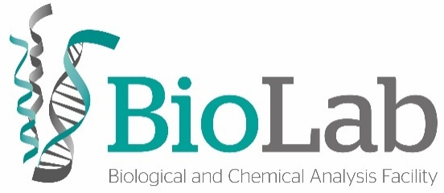
Circular Dichroism
(CD)
Analysis Request

- Applicant Information
Name
Email |  | Phone
Supervisor |  | Supervisor email
Group/Lab |  | Phone extension

- Assay Information
If you have more then one sample but assay conditions are the same you just need to submit one form.
- Spectra
Sample name
Sample type (protein, peptide, organic compound, nucleic acid…)
Concentration
Temperature
Buffer
Cuvette pathlength
Wavelengths | to
Bandwidth
(default 1 nm)
Step
(default 1 nm)
Time per point
Number of repeats
Sample return
(when applicable and to be collected in the laboratory; yes/no)

- Temperature Ramp

Sample name
Sample type (protein, peptide, organic compound, nucleic acid…)
Concentration
Buffer
Cuvette pathlength
Wavelengths |  | to
Bandwidth
(default 1 nm)
Step
(default 1 nm)
Time per point
(default is adjusted to each scan take 1 min)
Continuous Ramp |  | Stepped Ramp
Start temperature |  | Start temperature
End temperature |  | End temperature
Step |  | Step
Rate |  | Incubation time
At the end of the ramp go to
(start temperature/end temperature/ defined temperature)
Take a final measure (Yes/No)
Return ramp (Yes/No)

Notes:
(please fill in with information you consider relevant, e.g. abbreviations used on tube identification, sample details and requirements, etc.)

Sample requirements:
- Buffers for CD spectroscopy must not contain any materials that are optically active and should be as transparent as possible. The total absorbance of the sample, including the buffer and cell, should be below one for high quality data.
- Buffer components (especially those that contain carboxylates) that have a high absorbance below 200 nm must be avoided (e.g. Tris, dithiothreitol, histidine, chloride, etc.).
- Samples for CD analysis should be free of particulate matter. They can be filtered through filters (e.g. 0.1–0.2 micron).
- An exact protein concentration determination is crucial for CD analysis.
- Far-UV CD: typical cell pathlengths are in the range 0.01 to 0.05 cm and protein concentrations are in the range 0.2 to 1 mg/ml (generally 100 to 500 µg of sample but spectra can be obtained with quantities as low as 10 µg). The optimal protein concentration is a function of the pathlength of the cuvette.
- Near UV CD: Protein concentration of 0.5 to 2 mg/ml and a pathlength of 0.5 to 2 cm. The amounts of protein required are thus of the order of several mg.
- Nucleic Acids: CD can work with DNA amounts as low as 25 µg. The concentration of DNA can also be very low (20 µg/ml).
- Available Cuvettes at BioLab. You just need 2/3 off the total volume to perform the experiment.
Cuvette | Type | Pathlength (mm) | Total Volume (µl)
Hellma QS 110-10-40 | Retangular | 10 | 3500
Hellma QS 110-2-40 | Retangular | 2 | 700
Hellma QS 110-1-40 | Retangular | 1 | 350
Hellma QS 121-0.2-40 | Circular | 0.2 | 170
Hellma QS 121-0.1-40 | Circular | 0.1 | 160

Results will be sent exclusively by email in the .csv format.
If you need help with result analysis please contact the technician.

Contacts:
Elisabete Ferreira
ep.ferreira@fct.unl.pt
+351 937556792

BioLab
Laboratório 213
Piso 2, Faculdade de Ciências e Tecnologia
Universidade Nova de Lisboa
Campus de Caparica
2829-516 Caparica
Portugal
+351 212948300 #10958
Submission date: Analysis date:

